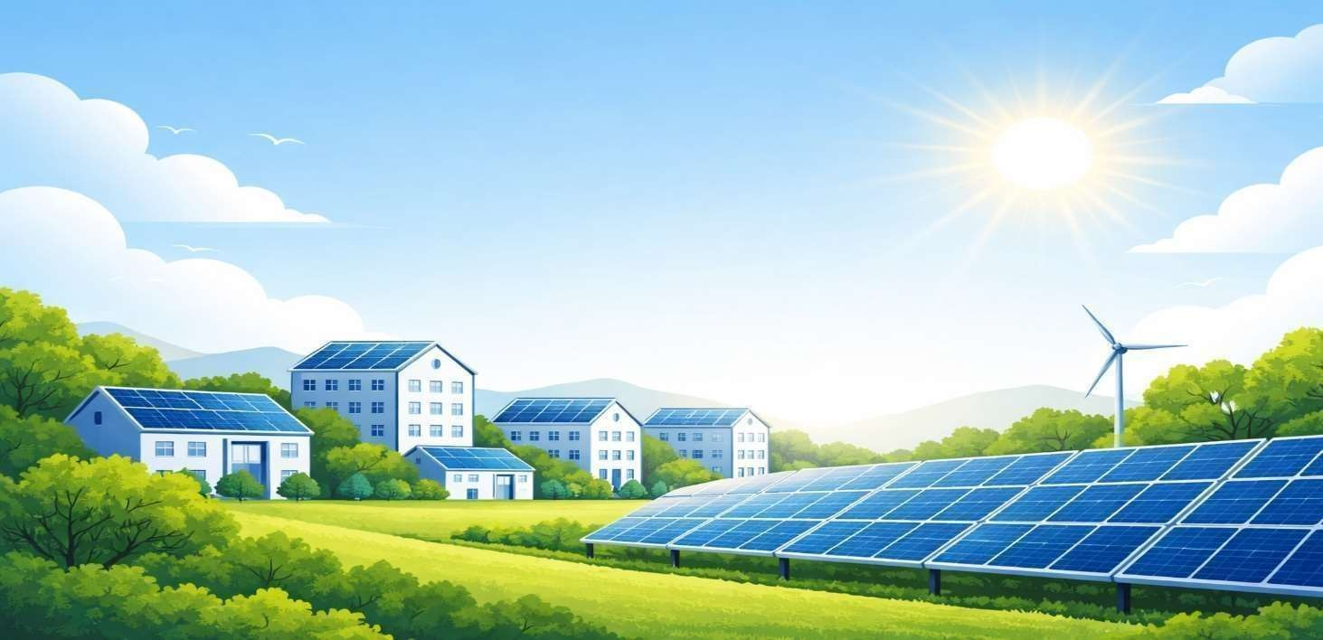

Proposal for
Rahane Residential
| 10 kWp Ongrid Rooftop Solar Plant |

Client | rahane
Location
Proposed Solar Capacity | 10 kWp On grid Rooftop Solar Plant

Our Company Overview

Sesola Power Projects Pvt Ltd, operating under the brand Sesola Energy, is a leading Engineering, Procurement, and Construction (EPC) company established in 2017, specializing in solar and power infrastructure solutions.

The company delivers end-to-end turnkey solutions covering design, engineering, procurement, installation, testing, and commissioning of solar power projects, with a strong focus on quality, efficiency, and sustainability.

With a commitment to innovation and performance, Sesola provides advanced solar systems that maximize energy generation and reduce operational costs for clients.
Sesola has cumulatively completed over 300 MW of solar power projects across India, demonstrating its strong execution capability, technical expertise, and trusted industry presence.

Our Expertise

Sesola has developed strong expertise in multiple domains of renewable energy and electrical infrastructure:
- Rooftop Solar Projects
- Ground Mounted Solar Plants
- Floating Solar Systems
- Solar Carports
- Substations & Transmission Lines: Successfully completed execution of 132 kV substations
and 220 kV transmission lines.
- Electrical Infrastructure Works
The company also undertakes LT/HT panel installation, electrification works, and power distribution systems for industries, hospitals, and commercial facilities.

EPC Capabilities

Sesola offers complete turnkey EPC services, ensuring seamless execution of projects:
- Detailed Engineering & Design
- Procurement of Tier-1 Equipment
- Civil & Electrical Installation
- Testing & Commissioning
- Grid Synchronization & Net Metering

Each project is customized to client requirements to ensure maximum efficiency, cost optimization, and long-term performance.

Innovation & R&D

Sesola Energy emphasizes continuous innovation through its Research & Development (R&D) division, focusing on:
- Improving system efficiency
- Developing advanced solar technologies
- Enhancing performance and durability
- Delivering cost-effective energy solutions
This commitment ensures the company stays ahead in the evolving renewable energy sector.

Global Presence:

Headquartered in Hyderabad, India, Sesola has expanded its footprint internationally, executing projects in:
- Dubai
- Singapore
This global exposure enables the company to handle diverse project requirements and regulatory environments with high efficiency.

Safety & Quality Commitment:

At Sesola Power Projects Pvt Ltd, safety is a core priority in all phases of project execution. We strictly adhere to industry safety standards and best practices to ensure a safe working environment for our workforce and stakeholders.
Our safety practices include:
- Implementation of standard safety protocols at all project sites
- Use of Personal Protective Equipment (PPE) for all personnel
- Regular safety training and toolbox talks for workers
- Compliance with electrical and structural safety standards
- Routine inspections and risk assessments
We are committed to achieving zero-incident project execution while maintaining the highest levels of quality and operational excellence.

Our Sample PROJECT EXECUTION / INSTALLATION WORKS
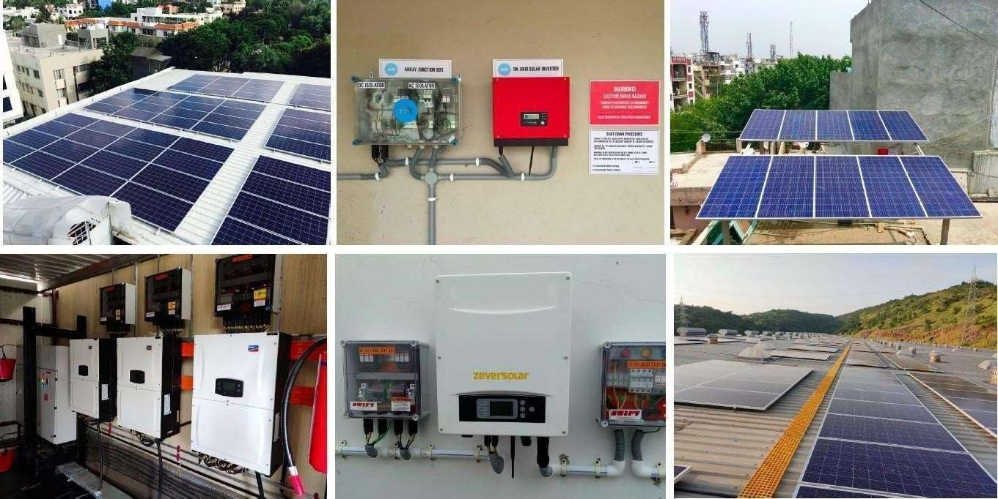
About the System
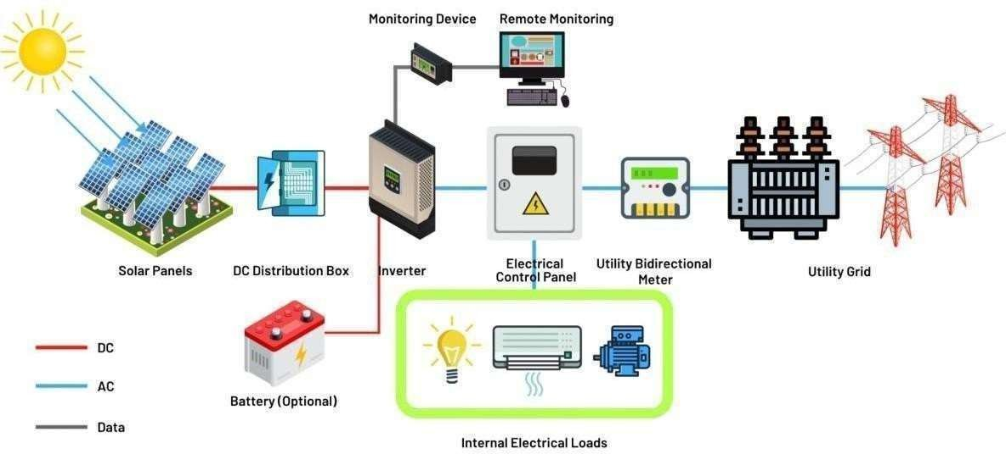

How Net Metering Works
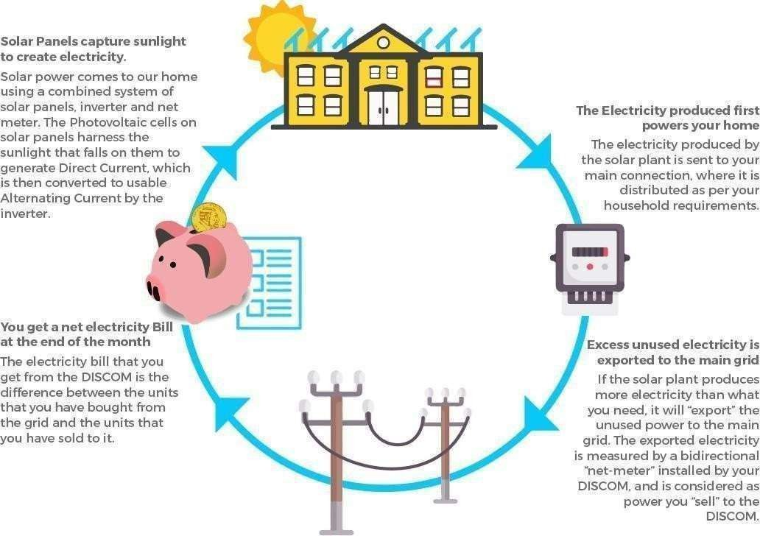
Financial Pricing

S.No | Description of Work | Price for 10 kWp Plant | GST  % | GST  Amount | Total Cost
1 | 10 kWp Rooftop Solar PV Plant with DCR panels | ₹36,000 | 8.9% | ₹3,204 | ₹39,204

Amount in Words: Rupees Thirty Nine Thousand Two Hundred Four Only.

Subsidy Details:-
- Central Government Subsidy Applicable: ₹78,000
- Subsidy will be credited directly to the customer's bank account as per MNRE norms.
- Subsidy is subject to approval from the concerned authorities and compliance with prevailing MNRE guidelines.
- Customer has to register on the National Portal for Rooftop Solar and complete all required formalities for subsidy claim.

ROI Analysis – 10 kWp Solar System
S.No | Particular | Value
1 | Proposed Solar Plant Capacity | 10 kWp
2 | Total Project Cost (Excl. GST) | ₹36,000
3 | GST @ 8.9% | ₹3,204
4 | Total Project Cost (Incl. GST) | ₹39,204
5 | Electricity Tariff Considered | ₹4 / Unit
6 | Specific Energy Generation | 1,460 Units/kWp/Year
7 | Annual Energy Generation | 14,600 Units
8 | Annual Electricity Savings | ₹58,400
9 | Monthly Average Savings | ₹4,867
10 | Simple Payback Period | 0.7 Years
11 | Annual ROI | 148.96%
12 | Estimated System Life | 25+ Years
13 | Lifetime Energy Generation | 3,65,000 Units
14 | Lifetime Electricity Savings | ₹14,60,000
15 | Net Lifetime Financial Benefit | ₹14,20,796

Note:

- Quote valid for 10 days from Tuesday (04-08-26).
- Estimated ROI (Return on Investment) period is approximately 4 to 5 years based on average power consumption and generation conditions.
- Net Metering and CEIG process is in SESOLA scope.
- Banking process and EB related documentation support from customer side will be required wherever applicable.
- Transportation included.
- Project execution timeline: 30 to 45 working days from date of advance payment and approval.
- Warranty:
  - Solar Modules: 25 years
  - Inverter: 8 years
  - Installation workmanship warranty by SESOLA as applicable.

Bill of Material

Sl. No | Component | Specifications | Make | Qty | Units
1 | PV Modules | 620 Wp · TOPCon · N-Type · Monofacial · DCR | Tata 620 wP | 20 | Nos
2 | Inverter | 4 kW · String · Three Phase · 4 · 98.2 % | Polycab 4kW | 3 | Nos
3 | DCDB | IP65 · Type 2 · 1000 V · 1 in 1 out | ABB 1-in-1-out | 1 | Nos
4 | ACDB | IP65 · Type 2 · 100 A · 4P | ABB 100A 4P | 1 | Nos
5 | Module Mounting Structure | Hot Dip Galvanized Iron · RCC Rooftop · 50 m/s | Tata HDGI | 1 | Set
6 | Module Fixing Nuts & Bolts | M8 · SS304 · 25 mm | Standard M8 SS304 | 1 | Set
7 | DC Cable | 6 sqmm · 1C · Tinned Copper · 1500 V | Polycab 6sqmm | 1 | Meters
8 | Cement | OPC 53 · 50 kg | UltraTech OPC 53 | 1 | Bag
9 | Aggregate (Jelly) | 12mm · Crushed Stone | Approved Quarry 12mm | 1 | CFT
10 | Sand | River Sand | Approved Supply River | 2 | CFT
11 | Installation & Commissioning | Installation, testing & commissioning of the solar PV plant (labour) | energy | 12 | kW
12 | El |  |  | 12
13 | Solar Connectors (MC4) | 30 A · 1500 V · MC4 Compatible | Amphenol H4 | 12 | Pairs
14 | Earth Rod | 14.2 mm · 1 m · Copper Bonded · 100 microns | Excel 14mm | 12 | Nos
15 | Lightning Arrestor | ESE · 1 m · Single Spike | Indelec ESE | 12 | Nos
16 | 4sqmm Green wire | 4 sqmm | polycab | 12 | Nos
17 | Earthing Chemical Compound | 25 kg · Conductive Compound | Ashlok 25kg | 12 | Nos
18 | Earth Pit Chamber | 18x18 cm · FRP | Excel 18x18cm | 12 | Nos
19 | Cable Lugs | 4 sqmm · Pin · Copper | Dowells 4sqmm Pin | 12 | Nos
20 | PVC Conduit Pipe | 25 mm · ISI Heavy Duty · Black | Precision 25mm | 12 | Meters
21 | PVC Pipe Bend | L-Bend · 25 mm · ISI Heavy Duty | Precision 25mm L | 12 | Nos
22 | AC Cable | 50 sqmm · 4C · Aluminium · Armoured | KEI 4Cx50 | 12 | Meters

Thanks & Regards,

For Sesola Power Projects Pvt. Ltd.

Sudhakar G
+91-7013759123
Executive Manager – Procurement

